Jimmy Vang

Intro to Java

12/8/2016

**Testing Document**

**Lab Array_List**

**J**ava File Name(s): “Main, GoldReports, GoldDA, Gold” (using .java)

I wasn’t sure if I had to use the yearly list or daily list. By default, all the methods will return Gold Objects from the Daily Gold List.

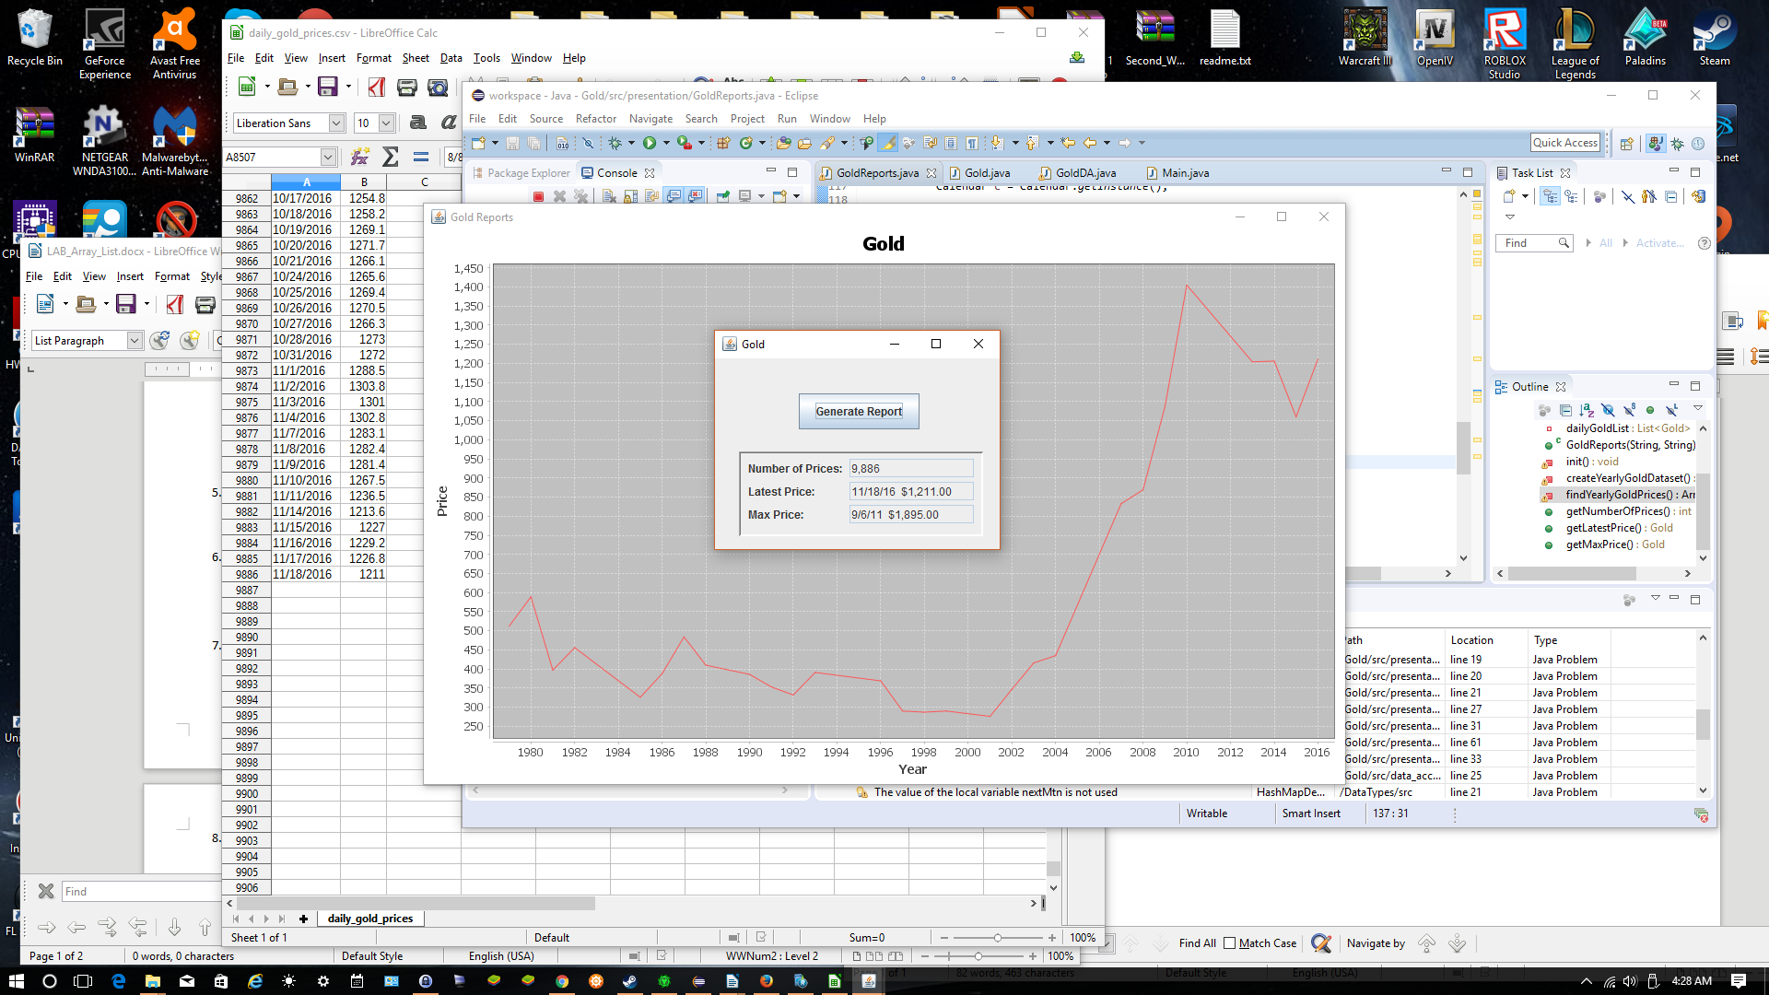 I tested the new fixed methods and compared the values to the chart. They seemed alright, but I also checked the CSV file incase of an error. The chart seemed to match the CSV data. Below is a screenshot of what values I got.